ShadeMates
Support Document
Smarter routes. Cooler journeys.
Presented by TP41 NightOwlz | FIT5120 Capstone Project 2026 S1

Product | Platform | Region | Document Type
ShadeMates | Android (Native) | Melbourne CBD | Production Support Handover

NOTE:
This document supports the day-to-day operation, user support, incident triage, and basic security maintenance of ShadeMates after handover. It is written for the Sponsor, Support Staff, and Technical Staff.

1. DOCUMENT CONTROL
Item | Content
Document Name | ShadeMates Support Document
Status | Production Support Handover · Live Document (reviewed each iteration)
Document Owner | ShadeMates Project Team (TP41 NightOwlz)
Publication Date | May 2026
Scope | ShadeMates Android application; coverage area: Melbourne CBD
Audience | Sponsor / Support Staff / Technical Staff
Related Documents | Product Document, Maintenance Document, Security Plan, Security Implementation Evidence, Threat & Risk Assessment, Data Management Plan (DMP)

1.1 Purpose
This document answers one core question:
[NOTE] "If I were taking over ShadeMates today, how would I run it, support its users, and keep the system healthy?"

It is written from the perspective of "usable by Support Staff every day", not as a pure technical reference.

2. AUDIENCE & RESPONSIBILITIES
Three roles jointly maintain ShadeMates after release:
Role | Primary Focus | Authorised Actions
Sponsor / Business Owner | Stable operation, user experience, risk visibility | Read this document; track key risks and release status
Support Staff | User issues, daily checks, reproducible front-line incidents | Run health checks, reproduce issues, give first-line guidance, escalate
Technical Staff | Configuration changes, integration issues, security incidents, complex faults | AWS, databases, backend, security controls, release management

2.1 Escalation Flow
User feedback | → | Support reproduces | → | Apply this document | → | Technical Staff engages | → | Sponsor informed

[CAUTION] If the guidance in this document does not resolve a user's issue, escalate to Technical Staff.

3. SYSTEM OVERVIEW (FOR THE SUPPORT TEAM)
ShadeMates is a native Android application for residents of Melbourne CBD. It helps users choose safer walking routes under heat exposure.

3.1 Five Core Features
Feature | What users can do with it
Heat Map | View the current heat distribution across Melbourne CBD areas
Cool Route | Find a cooler walking route between two locations
UV & Weather | Check the current UV index and weather conditions
Cool Places | Discover nearby places to cool down or rest
Education (Awareness) | Read concise heat-health educational content

3.2 Technologies Actually Used (implemented items only)
Source: First Cut Technology Stack Document, Pair Programming Observation, Security Plan, Architecture Document, DMP.
Layer | Technology used
Client | Kotlin + Jetpack Compose + Material 3
Networking | Retrofit + Gson
Local cache | Room (SQLite)
Map rendering | Mapbox SDK
Backend entry | AWS API Gateway
Backend compute | AWS Lambda
Relational storage (source: DMP) | AWS RDS MySQL (db-shademate): application operational data
Spatial storage (source: DMP) | AWS RDS PostgreSQL + PostGIS (db-shademate-gis): buildings / transport
External data sources | OpenWeather, OpenStreetMap (buildings + transport), City of Melbourne

3.3 High-Level Data Flow (Visual Aid)
Android client | → | AWS API Gateway | → | AWS Lambda | → | RDS MySQL / PostGIS | → | OpenWeather

Client requests pass through API Gateway into Lambda; Lambda reads/writes RDS (MySQL and PostGIS) and calls OpenWeather when needed. The client uses Room (SQLite) for short-term caching.
[INFO] Support Staff do not need direct access to AWS or the databases. These are managed by Technical Staff.

3.4 Product UI Tour (Visual Aid)
The screenshots below are real screens from the ShadeMates Android client. They give Support Staff a baseline of "what should I see?" so abnormal user reports can be matched against the normal state.

▍ First launch: welcome page + personalisation
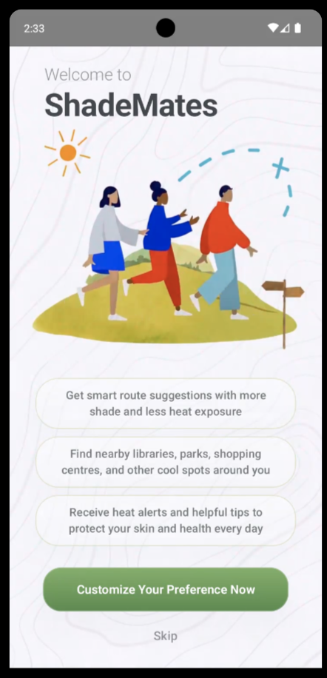 | 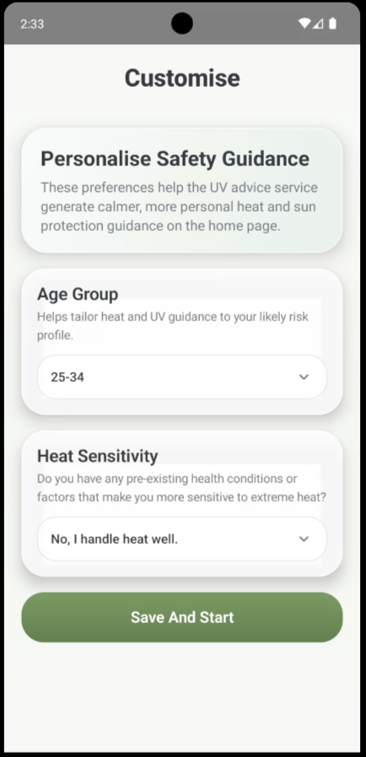
First-launch welcome page | Personalisation (age group / heat sensitivity)

▍ Home tab: bottom navigation + four quick-preview sub-tabs (All / Weather / Nearby / Map)
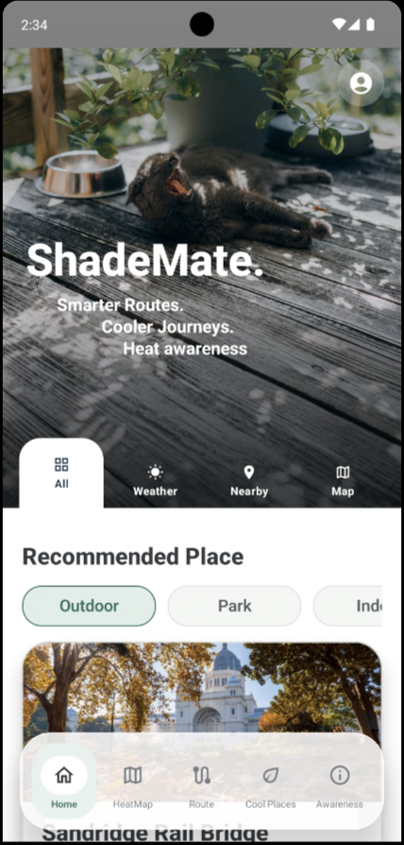 | 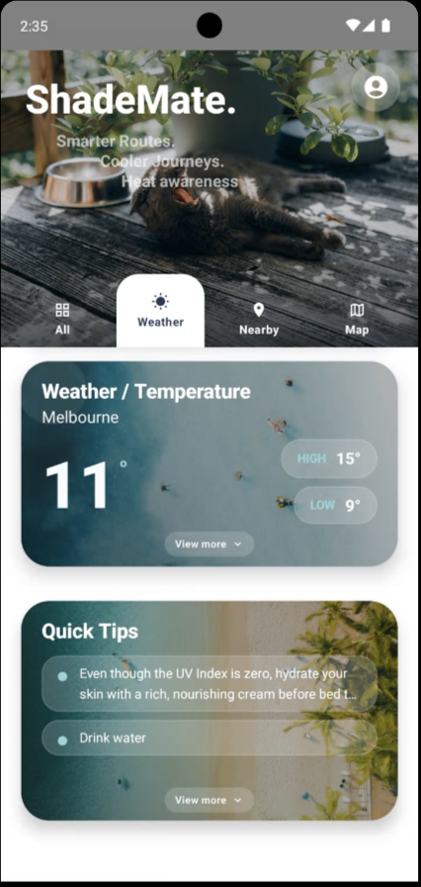 | 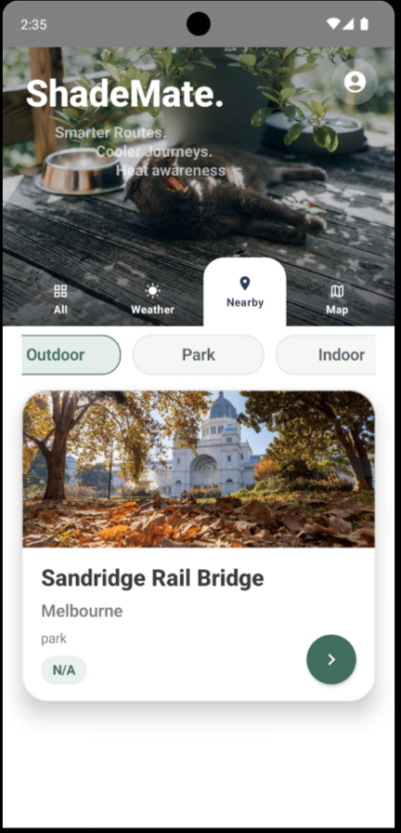 | 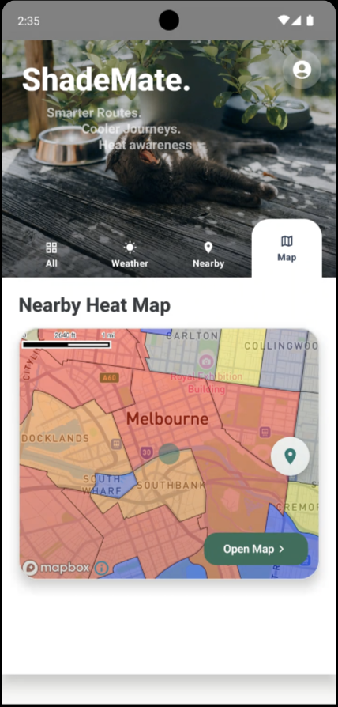
Home · All (default) | Home · Weather | Home · Nearby | Home · Map (heat-map preview)

▍ Five main feature screens (bottom nav: Home / HeatMap / Route / Cool Places / Awareness)
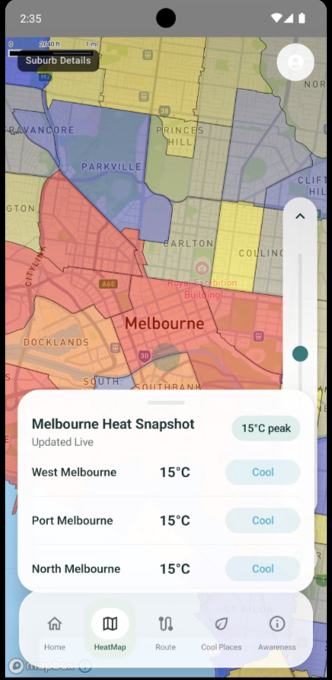 | 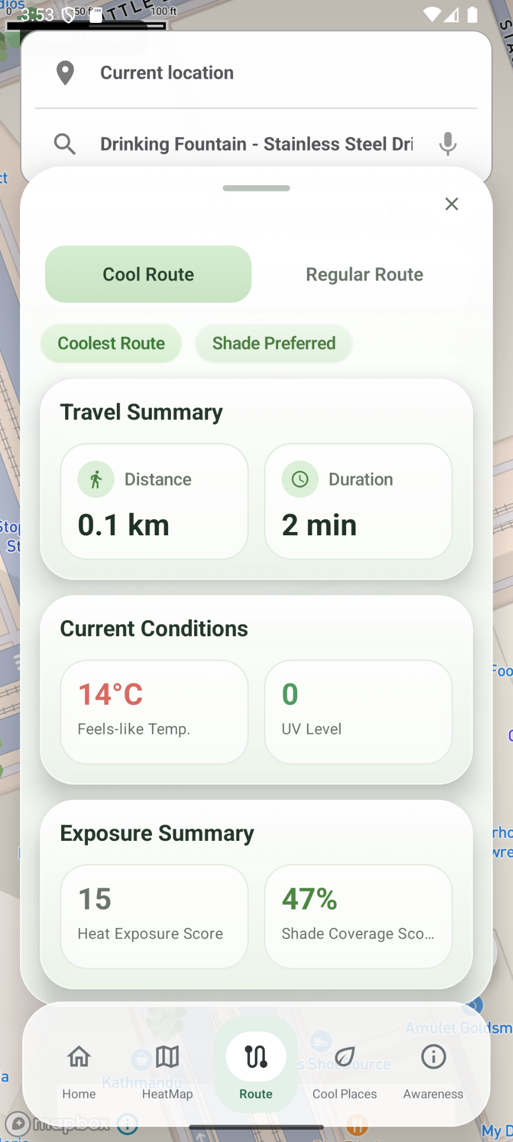 | 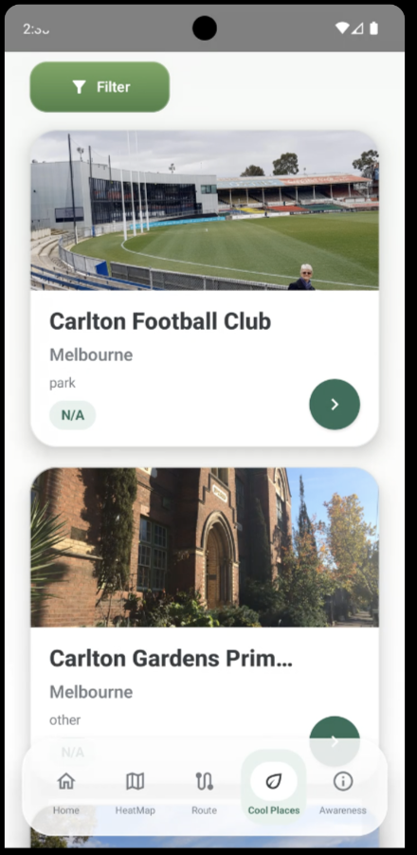 | 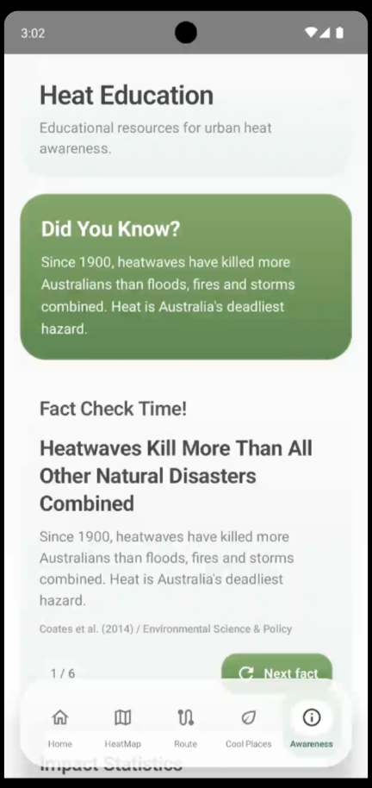
HeatMap · full heat map | Route · trip summary | Cool Places · list | Awareness · Heat Education

4. QUICK START: THE SUPPORT TEAM'S FIRST DAY
Purpose  Confirm in 10 minutes whether ShadeMates is healthy before handling user issues; also covers app start/stop and version updates. | Audience  Support Staff (first task each day) | Key Actions  1) Get ready → 2) Health check → 3) Anomalies: follow §8 → 4) Escalate if needed

4.1 Preparation
- An Android phone that can install ShadeMates
- The latest ShadeMates installer (APK or distribution link)
- Team support contact list (who to escalate to)
- Access to shared team documents (Product Doc, Maintenance Doc, Security Plan)

4.2 10-Minute Health Check
Number | Step | Expected outcome
1 | Open ShadeMates | Home page loads normally, no crash
2 | Open Heat Map | Map shows coloured heat zones
3 | Open Cool Route, enter a destination | Candidate routes appear within seconds
4 | Check UV & Weather | Values are present; timestamp is recent
5 | Open Cool Places and Education | Both screens load content
6 | General walk-through | No repeated crashes / red error banners

4.3 Health Criteria
- The app opens smoothly without lag or crash.
- All five main screens load and display content.
- No blocking errors prevent normal usage.
If any check fails, follow §8 Troubleshooting Matrix; for feature-specific symptoms, see §7.

4.4 First-Launch Flow (Visual Aid)
When a new user installs and first opens ShadeMates, they go through the two steps below. If a user reports being stuck on the personalisation page, Support Staff can guide them using these screenshots.
Step 1 · Welcome page → "Customize Your Preference Now" | Step 2 · Set age group + heat sensitivity → "Save And Start"

4.5 Start / Stop / Reinstall (user side)
Action | What the user does | When to use it
Restart app | Swipe ShadeMates away in recents, then open again | Page lag or one-off loading failure
Force stop | System Settings → Apps → ShadeMates → Force stop | Repeated misbehaviour that a restart does not fix
Clear cache | System Settings → Apps → ShadeMates → Storage → Clear cache | Local cache appears corrupted
Reinstall | Uninstall, then install the latest APK / distribution build | Suspected leftover state from an older version

4.6 App Distribution & Version Updates
ShadeMates is delivered as a native Android app, distributed exclusively by the project team. Support Staff only need to know three things: where to obtain the installer, how to confirm the version, and how users should upgrade.
Item | What Support Staff should know | Owner
Installer source | The team's official APK distribution link / build; never a third-party store | Technical Staff (release)
Confirm version | Read the version number inside the app and compare with the team's current version | Support Staff
User upgrade | Users re-open the distribution link to get the latest APK; overwrite-install works (no need to uninstall first) | Support Staff (guide users)
Emergency rollback | Technical Staff retract the link or republish the previous stable APK | Technical Staff
Old-version residue | If a user reports an issue, check the version first; advise upgrading if it is noticeably outdated | Support Staff

[CAUTION] Support Staff do not publish or retract any release. All publication, retraction, and gradual rollouts are performed by Technical Staff.

5. DAILY OPERATIONS (RUNBOOK)

5.1 Start-of-Day Check
- Open the app yourself and verify all five main screens behave normally.
- Check that the UV / Weather timestamps are recent.
- Watch the team support channel for new reports.

5.2 Information to Record for Each User Report
Capture the following five items for each user report:

Number | What to record
1 | What was the user doing at the time?
2 | What did the user see (screenshot if possible)?
3 | Which feature screen was it?
4 | Any recent changes (new version, network, location)?
5 | When did the issue occur?

Then handle the report via §7 (by feature) or §8 (Troubleshooting Matrix); if security or privacy indicators are involved, see §9 Security & Confidential Information.

5.3 End-of-Day Wrap-Up
- Summarise issues resolved and unresolved during the day.
- Watch for patterns (e.g. multiple Cool Route timeouts at lunchtime) and report them to Technical Staff.

5.4 Support Flow Overview (Visual Aid)
Receive report | → | Reproduce | → | Check this doc | → | Apply first-line steps | → | Unresolved → escalate

6. DATA, BACKUP & RESTORE (SOURCE: DMP)
Purpose  Give Support Staff a working understanding of how data flows, where it is stored, and how it is backed up — enough to recognise anomalies when users report stale or wrong data and to escalate appropriately. | Audience  Support Staff (concepts) + Technical Staff (execution) | Key Actions  Identify the relevant data source → check timestamps → coordinate restore per §6.5 when needed

6.1 Data Distribution
Data type | Storage location | Notes
Operational data | AWS RDS MySQL (db-shademate) | Users, preferences, heat-zone records, UV samples, cool places, education content
Spatial data | AWS RDS PostgreSQL + PostGIS (db-shademate-gis) | Buildings / transport network (source: DMP)
Live UV / Weather | Backend calls OpenWeather | Client never calls upstream directly
On-device cache | Room (SQLite) | Most recent data still visible on weak networks

The data layering and persistence strategy above is sourced from the DMP (ShadeMates Data Management Plan).

6.2 Data Refresh Flows
Source | Refresh approach | Affected features
OpenWeather UV / Weather | Live fetch + short backend-side caching to stay within upstream quotas | UV & Weather and related health prompts
OSM Buildings / Transport | Land in the raw layer first, then cleaned into the analytical layer (source: DMP) | Heat Map, Cool Route
UV sampling | One sample written to MySQL every hour | Heat Map historical data

6.3 Initial Load & Refresh Detail (source: DMP)
The table below explains, per data source, how data is first loaded and how it is refreshed in production. Support Staff only need to understand the concept; anomalies are handled per §8 Troubleshooting Matrix.
Data source | Initial load | Ongoing refresh | Storage | Owner on incident
OSM Buildings | Pulled via Overpass API for the Melbourne CBD bounding box into the raw layer, then cleaned into the analytical layer | Cleaning script re-run on demand (no fixed cadence) | AWS RDS PostgreSQL + PostGIS | Technical Staff
OSM Transport | Pulled via Overpass API for road / walking / cycling networks into the raw layer, then filtered into the analytical layer | Cleaning script re-run on demand | AWS RDS PostgreSQL + PostGIS | Technical Staff
OpenWeather UV / Weather | No initial load (live fetch) | Backend calls on demand + short-term server-side cache | Cached in the Lambda layer | Technical Staff
UV historical samples | Scheduled job writes one sample per hour | One sample per hour (source: DMP) | AWS RDS MySQL | Technical Staff
Cool Places / Education content | Pre-loaded by the team; can be extended on a maintenance plan | Updated by maintainers on demand | AWS RDS MySQL | Technical Staff

6.4 Backup & Restore
Data object | Backup method | Frequency | Retention | Owner
AWS RDS MySQL (operational data) | RDS automated snapshots (source: DMP) | Daily | 7 days | Technical Staff
AWS RDS PostgreSQL + PostGIS (spatial data) | Analytical layer can be rebuilt by cleaning scripts; raw layer is protected by RDS backups | On demand + daily RDS snapshots | 7 days | Technical Staff
Client Room cache | No backup required (device-local cache) | / | / | /

6.5 Restore Procedure (performed by Technical Staff; Support Staff to be aware)
Confirm scope | → | Pick point-in-time | → | Execute restore | → | Verify service | → | Re-open to users

6.6 When a user reports "data looks wrong or stale"
Number | Action
1 | Check the timestamp on the UV / Weather card.
2 | Ask the user to pull-to-refresh.
3 | If multiple users report the same issue, escalate to Technical Staff.

7. FEATURE-BY-FEATURE SUPPORT PLAYBOOK
Purpose  Per-feature support guidance in a uniform structure so Support Staff can quickly match a user report to the right playbook. | Audience  Support Staff | Key Actions  Read "normal behaviour" → guide the user through "first things to try" → escalate at "when to escalate"

Each feature follows the same structure: purpose → normal behaviour → questions to ask → first things to try → when to escalate.

7.1 Heat Map
Aspect | Detail
Purpose | Display the current heat distribution across areas of Melbourne CBD.
Normal behaviour | Map loads with coloured zones; users can pan and zoom.
Ask the user | Is the map blank? Are colours missing? Is it very laggy?
First things to try | 1) Close and re-open the app; 2) Check the phone's network; 3) If the feature uses "nearby", confirm that location permission is granted.
When to escalate | Multiple users in a row cannot see the map.

Reference screenshots — normal state:
Home · Map sub-tab: heat-map preview entry | Full heat map + Melbourne Heat Snapshot drawer

7.2 Cool Route
Aspect | Detail
Purpose | Recommend a cooler walking route between two locations.
Normal behaviour | After entering a destination, candidate routes appear within seconds.
Ask the user | What is the origin and destination? Is the app stuck loading, or is there an outright error?
First things to try | 1) Have the user re-enter the destination; 2) Try a well-known place (e.g. "State Library"); 3) Check the network.
When to escalate | Even valid Melbourne locations cannot return a route, or multiple users fail at the same time.

Reference screenshots — normal state:
 | 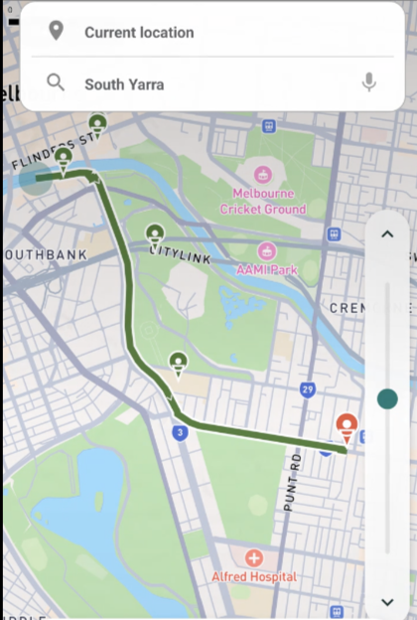
Cool Route: Travel Summary / Current Conditions | Cool Route: green recommended path

7.3 UV & Weather
Aspect | Detail
Purpose | Show the current UV index and weather, with safe-exposure prompts.
Normal behaviour | Cards show values; the timestamp is recent.
Ask the user | Is the value blank, stale, or clearly unreasonable?
First things to try | 1) Pull-to-refresh; 2) Re-open the app; 3) If a value looks clearly wrong, cross-check against a public source.
When to escalate | UV or weather is unavailable or long-stale for all users.

Reference screenshots — normal state:
Home · Weather: temperature card + Quick Tips

7.4 Cool Places
Aspect | Detail
Purpose | Show nearby places where users can cool down or rest.
Normal behaviour | A list is visible; tapping an item shows its details.
Ask the user | Is the list empty, are details missing, or is the location clearly wrong?
First things to try | 1) Have the user re-open the app; 2) If the feature uses "nearby", confirm that location permission is enabled.
When to escalate | The list is empty for multiple users, or the data is clearly wrong.

Reference screenshots — normal state:
 | 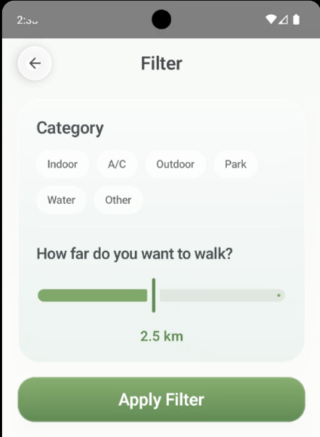
Cool Places list | Cool Places filter: Category + walking distance

7.5 Education (Awareness)
Aspect | Detail
Purpose | Under the bottom-nav Awareness tab, present concise heat-related education to users (Heat Education): a "Did You Know" card plus Fact Check flip-cards, each citing its source (e.g. Coates et al. 2014 / Environmental Science & Policy).
Normal behaviour | Screen title shows "Heat Education" with the subtitle "Educational resources for urban heat awareness"; the green "Did You Know?" card is visible; below it, the Fact Check area lets the user tap "Next fact" to flip through cards, with a pagination indicator such as "1 / 6".
Ask the user | Is the whole page failing to open, or does a specific fact card have no content / no citation / a non-responsive "Next fact" button?
First things to try | 1) Have the user re-open the app and return to the Awareness tab; 2) Tap "Next fact" to try the next card; 3) If the citation area looks broken, capture the card number (e.g. 1/6, 3/6).
When to escalate | The whole page is blank, all fact cards have no content, or "Next fact" is unresponsive for multiple users.

Reference screenshots — normal state:
Awareness · Heat Education: Did You Know? card + Fact Check flip-cards

Heat Education under the Awareness tab and the Quick Tips inside Home · Weather are two different surfaces for educational content: the former flips through fact cards, the latter shows short prompts.

8. TROUBLESHOOTING MATRIX
Purpose  Match user-visible symptoms to the most likely cause, the first response, and an escalation threshold; severity tags help prioritise quickly. | Audience  Support Staff (front line) | Key Actions  Read P0/P1/P2 → match "What users see" → run "First things to try" → escalate at "When to escalate"

Severity legend:
Severity | Meaning
P0 | Main feature blocked;  multiple users affected → escalate immediately
P1 | A single key feature is affected or experience is clearly degraded
P2 | Minor or workable local issue

Severity | What users see | Most likely cause | First things to try | When to escalate
P0 | App opens but main screen is empty | Network or backend issue | Restart app → check network | Lasts several minutes or affects many users
P0 | Heat map does not appear | Map service or data issue | Restart app → try another device | All users cannot see the map
P1 | Cool Route returns nothing | Routing service or input issue | Retry with a familiar place → check input | Even valid places fail to return
P1 | UV / Weather stale or empty | Upstream weather issue | Pull-to-refresh → re-open app | Multiple users affected and long stale
P1 | Cool Places list is empty | Data or permission issue | Confirm location permission → re-open app | All users see an empty list
P2 | Education content is blank | Content fetch failure | Re-open app → try another card | All cards are blank
P0 | Repeated errors / suspected security issue | Abnormal usage or service issue | Do not share details; record context | Escalate immediately in all cases

9. SECURITY & CONFIDENTIAL INFORMATION
Purpose  Describe the security controls already in place, the day-to-day rules Support Staff must follow, and known residual risks. | Audience  All readers (Sponsor / Support / Technical) | Key Actions  Never expose secrets or stack traces → escalate anomalies immediately → timestamps and multi-user reports are early indicators

This section is based strictly on the Security Plan, Security Implementation Evidence, and Threat & Risk Assessment.

9.1 Implemented Security Controls
Control | What is actually done
Release signing | Release builds are signed with the official key.
Debug mode disabled | Debug mode is no longer enabled in release builds.
Android backup disabled | allowBackup=false;  app data is not silently backed up externally.
Log hygiene | Log output that could leak internal information or secrets has been removed.
Input sanitisation | Search and route inputs go through InputSanitizer to prevent malformed input.
API security testing | Postman is used for negative tests covering valid requests, missing/invalid API keys, parameter tampering, and injection-style inputs; MobSF is used to scan the Android build.

9.2 Rules Support Staff Must Follow
[CRITICAL] Never expose API keys, tokens, internal URLs, or backend stack traces in tickets, screenshots, chat logs, or any external communication. If a leak is suspected, escalate to Technical Staff immediately.

- Never paste raw error messages or stack traces to users.
- Keep user-facing guidance simple and actionable; do not expose technical details.
- Escalate to Technical Staff immediately on suspected key leaks, unusual traffic, or repeated authentication failures.

9.3 Known Residual Risks (source: Threat & Risk Assessment)
Risk | Description | Support Staff focus
Offline fallback is incomplete | User experience is not yet fully protected when the backend is unreachable | Escalate promptly when many users see empty content
Backend monitoring & alerting are not yet hardened | Operations rely on manual checks and user reports | Watch UV / Heat Map timestamps and multi-user reports
Risk of "stale or wrong" data | Long-stale UV / Heat Map data can affect health decisions | Verify timestamps; escalate patterns quickly

10. INTEGRATIONS, DATA & API

10.1 Integrations & Graceful Degradation
Dependency | Capability provided | Impact if unavailable | Degradation strategy | Support Staff action
Mapbox SDK + Web Services | Map rendering, geocoding, routing | Heat Map / Cool Route unusable | Client shows an empty map placeholder + error prompt | Reproduce with multiple users → record → escalate
OpenWeather (via backend) | UV index and real-time weather | UV / Weather cards blank or stale | Backend serves short-cached values or shows "temporarily unavailable" | Check timestamp → if multi-user → escalate
OpenStreetMap (Buildings + Transport) | Spatial data | Long-term accuracy of heat zones and routes affected | Continue using the most recent cleaned analytical layer | Does not block live availability → report to Technical Staff
AWS API Gateway + AWS Lambda | Backend entry and compute | App cannot fetch data; most features fail | Client falls back to recent data in the Room cache where possible | Escalate to Technical Staff immediately
AWS RDS MySQL / PostgreSQL + PostGIS (source: DMP) | Application and spatial data storage | Backend returns no content | Server returns degraded responses; client relies on the local cache | Escalate to Technical Staff immediately

[CAUTION] Support Staff handle incidents uniformly as: reproduce → record → escalate. Never contact upstreams directly. See §9.2 for confidential-information rules.

10.2 API & Traffic Principles
- Clients do not hold upstream service keys directly; all upstream calls go through AWS Lambda.
- The backend uses short-term caching and basic rate limiting to stay within upstream quotas (source: DMP).
- When calling OpenWeather, no user identity is passed upstream (source: DMP §11).
- Support Staff do not call any API directly; API-level triage is performed by Technical Staff.

11. COMPLIANCE & STANDARDS (SOURCE: DMP §6 / §11)
Purpose  Consolidate the licences and standards ShadeMates follows for data use, attribution, and data minimisation; includes the references list. | Audience  Sponsor / Support Staff / Technical Staff (compliance review) | Key Actions  Verify attribution against the licence list → cite §11.2 [R1]–[R15] when answering compliance questions

ShadeMates uses each data source strictly under its terms of use:
Source | Usage | Attribution
OpenStreetMap (Buildings + Transport) | Used under the ODbL licence | In-app attribution "OpenStreetMap contributors" (source: DMP)
OpenWeather | Used under the developer free tier | Comply with attribution and rate limits (source: DMP)
Mapbox | Used under Mapbox Terms of Service | Default SDK attribution must not be hidden (source: DMP)
City of Melbourne | Used under City of Melbourne Open Data Licence | Cite the source where data is used (source: Product Doc + DMP)

11.1 Privacy & Data Minimisation (source: DMP §11)
- User location is not written to LOCATION_LOG by default.
- USER_PREFERENCE.loc_sharing_enabled defaults to FALSE; users must explicitly opt in to enable location sharing.
- When calling OpenWeather, the backend strips user_id, email, and device identifiers, and passes no user identity upstream.
- The on-device Room cache only stores environmental data (UV / Weather / Cool Places) and never health-related personal traits.

11.2 References & Sources
All factual statements in this support document are drawn from the internal team documents and public licences listed below. No technology or external dependency that is not actually used by ShadeMates has been introduced.
Ref | Title | Supports which sections
[R1] | FIT5120 Handover Package Guidelines | Overall delivery requirements; §1 purpose
[R2] | Handover Document Rubric | Overall structure and HD scoring criteria
[R3] | FIT5120 Project Governance Portfolio Guidelines | Live Document nature; §1 document control
[R4] | ShadeMates Product Document | §3 system overview; §7 feature-by-feature support
[R5] | First Cut Technology Stack Document | §3.2 technologies actually used
[R6] | Pair Programming Observation | §3.2 stack and collaboration context
[R7] | ShadeMate High-Level System Architecture | §3.3 high-level data flow
[R8] | ShadeMate Security Plan (Live Document) | §9 security & confidential information
[R9] | ShadeMates Security Implementation Evidence | §9.1 implemented security controls
[R10] | ShadeMates Threat & Risk Assessment | §9.3 known residual risks
[R11] | ShadeMates Data Management Plan (DMP) | §6 data / §10 integration / §11 compliance (wherever "source: DMP" appears)
[R12] | OpenStreetMap ODbL License | §11 compliance (Buildings / Transport attribution)
[R13] | OpenWeather Terms of Service | §11 compliance (free-tier limits and attribution)
[R14] | Mapbox Terms of Service | §11 compliance (default SDK attribution)
[R15] | City of Melbourne Open Data Licence | §11 compliance (open data such as Cool Places)

Cross-reading aid: every "source: DMP" in the body refers to [R11]; security controls and residual risks map to [R8] [R9] [R10]; the five features map to [R4]; the technology stack maps to [R5] [R6] [R7].

12. KNOWN LIMITATIONS & OUT-OF-SCOPE

12.1 Known Limitations (source: DMP §12, Risk Assessment, Product Doc)
- ShadeMates only covers Melbourne CBD; areas outside CBD are not currently supported.
- Live weather accuracy is bounded by OpenWeather's accuracy at the time.
- Some OSM building heights are missing; a documented fallback value is used, which may still introduce minor deviation.
- Full offline fallback is still a follow-up work item.
- Hardened backend monitoring and alerting are still a follow-up work item.

12.2 What Support Staff Should NOT Handle Directly
- Algorithm logic changes (heat scoring, route scoring)
- New features or new integrations
- Database schema, infrastructure, or security-control changes
The items above are handled by Technical Staff and the project lead.

13. HANDOVER CHECKLIST & CONTACTS
Purpose  Final pre-handover checklist and the post-launch contact matrix for each role. | Audience  Project Lead / Sponsor / everyone involved in the handover | Key Actions  Tick each checklist item → complete the contact matrix → sign off with the next-phase owner

13.1 Pre-Submission Checklist
- Product, Support, and Maintenance documents are all included in the handover package
- The support team has completed end-to-end testing on a real device
- Security Plan and Security Implementation Evidence are attached
- Escalation paths to Technical Staff are confirmed
- Handover sign-off is complete

13.2 Contact Matrix
Role | Name | Email / Contact | Availability
Sponsor / Business Owner | Yosar Fatahillah  Xinyu Fan  Qi Yu | yosa0004@student.monash.edu  xfan0060@student.monash.edu  qyuu0028@student.monash.edu | Weekdays (9AM-6PM)
Support Lead | Ruwang Lin | rlin0044@student.monash.edu | Weekdays (9AM-6PM)
Technical Lead | Jiahui Qing | jqin0020@student.monash.edu | Weekdays (9AM-6PM)
Security Incident Contact | Raden Musa Saleh | rsal0026@student.monas.edu | Weekdays (9AM-6PM)

APPENDIX: GLOSSARY
Term / Acronym | Meaning
APK | Android Package; the Android application installer
API Gateway | AWS service that routes backend requests
CBD | Central Business District (Melbourne)
DMP | Data Management Plan (ShadeMates)
Lambda | AWS serverless compute service
OSM | OpenStreetMap; one of the project's spatial data sources
PostGIS | PostgreSQL spatial extension for geographic data
RDS | AWS Relational Database Service
Room | Android's SQLite wrapper; used here for on-device caching
UV | Ultraviolet Index

